# Quiz Bad data

## Question 1

This question involves NHANES processes described on the [previous page](https://www.futurelearn.com/courses/data-to-insight/4/quizzes/155843/introduction).

**Which of the following processes does NOT contribute to NHANES improving the quality of their data? Choose the FALSE answer.**

Participants are randomly selected using US Census information.

Participants receive benefits such as a free health and medical check with detailed results as well as payment for their time.

**Volunteers are accepted for the survey.**

Households are contacted and screened for their eligibility by an interviewer.

Medical Professionals carry out the health exam to ensure correct measurements and assessments of medical conditions are made.

Confidentiality is assured to encourage participants to be honest with their answers.

**Correct**

This statement is FALSE – Accepting volunteers is likely to cause bias in the data collection because volunteers are likely to be different in important ways from from people who don’t volunteer. In fact NHANES do not accept volunteers, only people who have been randomly selected.

Parte inferior do formulário

## Question 2

Parte superior do formulário

**Below is the graph of Blood Alcohol and Breath Alcohol readings taken by New Zealand Police as discussed in video 5.2.**

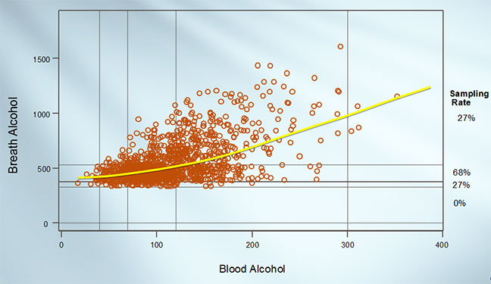

Which statement is incorrect about artefacts? Select the **FALSE**statement.

An artefact is a pattern that shows up in the data that is due to deficiencies in the data collection process.

**An artefact is an additional variable that we haven’t considered which affects both the Blood Alcohol and Breath Alcohol and outcome variables.**

The breath alcohol/blood alcohol demonstration in the preceding video showed how the presence of a curve in the trend could be an artefact due to the filtering process whereby which some people had their blood alcohol measured and others did not.

An artefact can lead us to incorrect conclusions about reality.

It can be hard to separate out artefacts from facts once the data is collected.

**Correct**

This statement is **FALSE** – A variable that affects both the predictor and outcome variable is called a confounding variable or a lurking variable.

Parte inferior do formulário